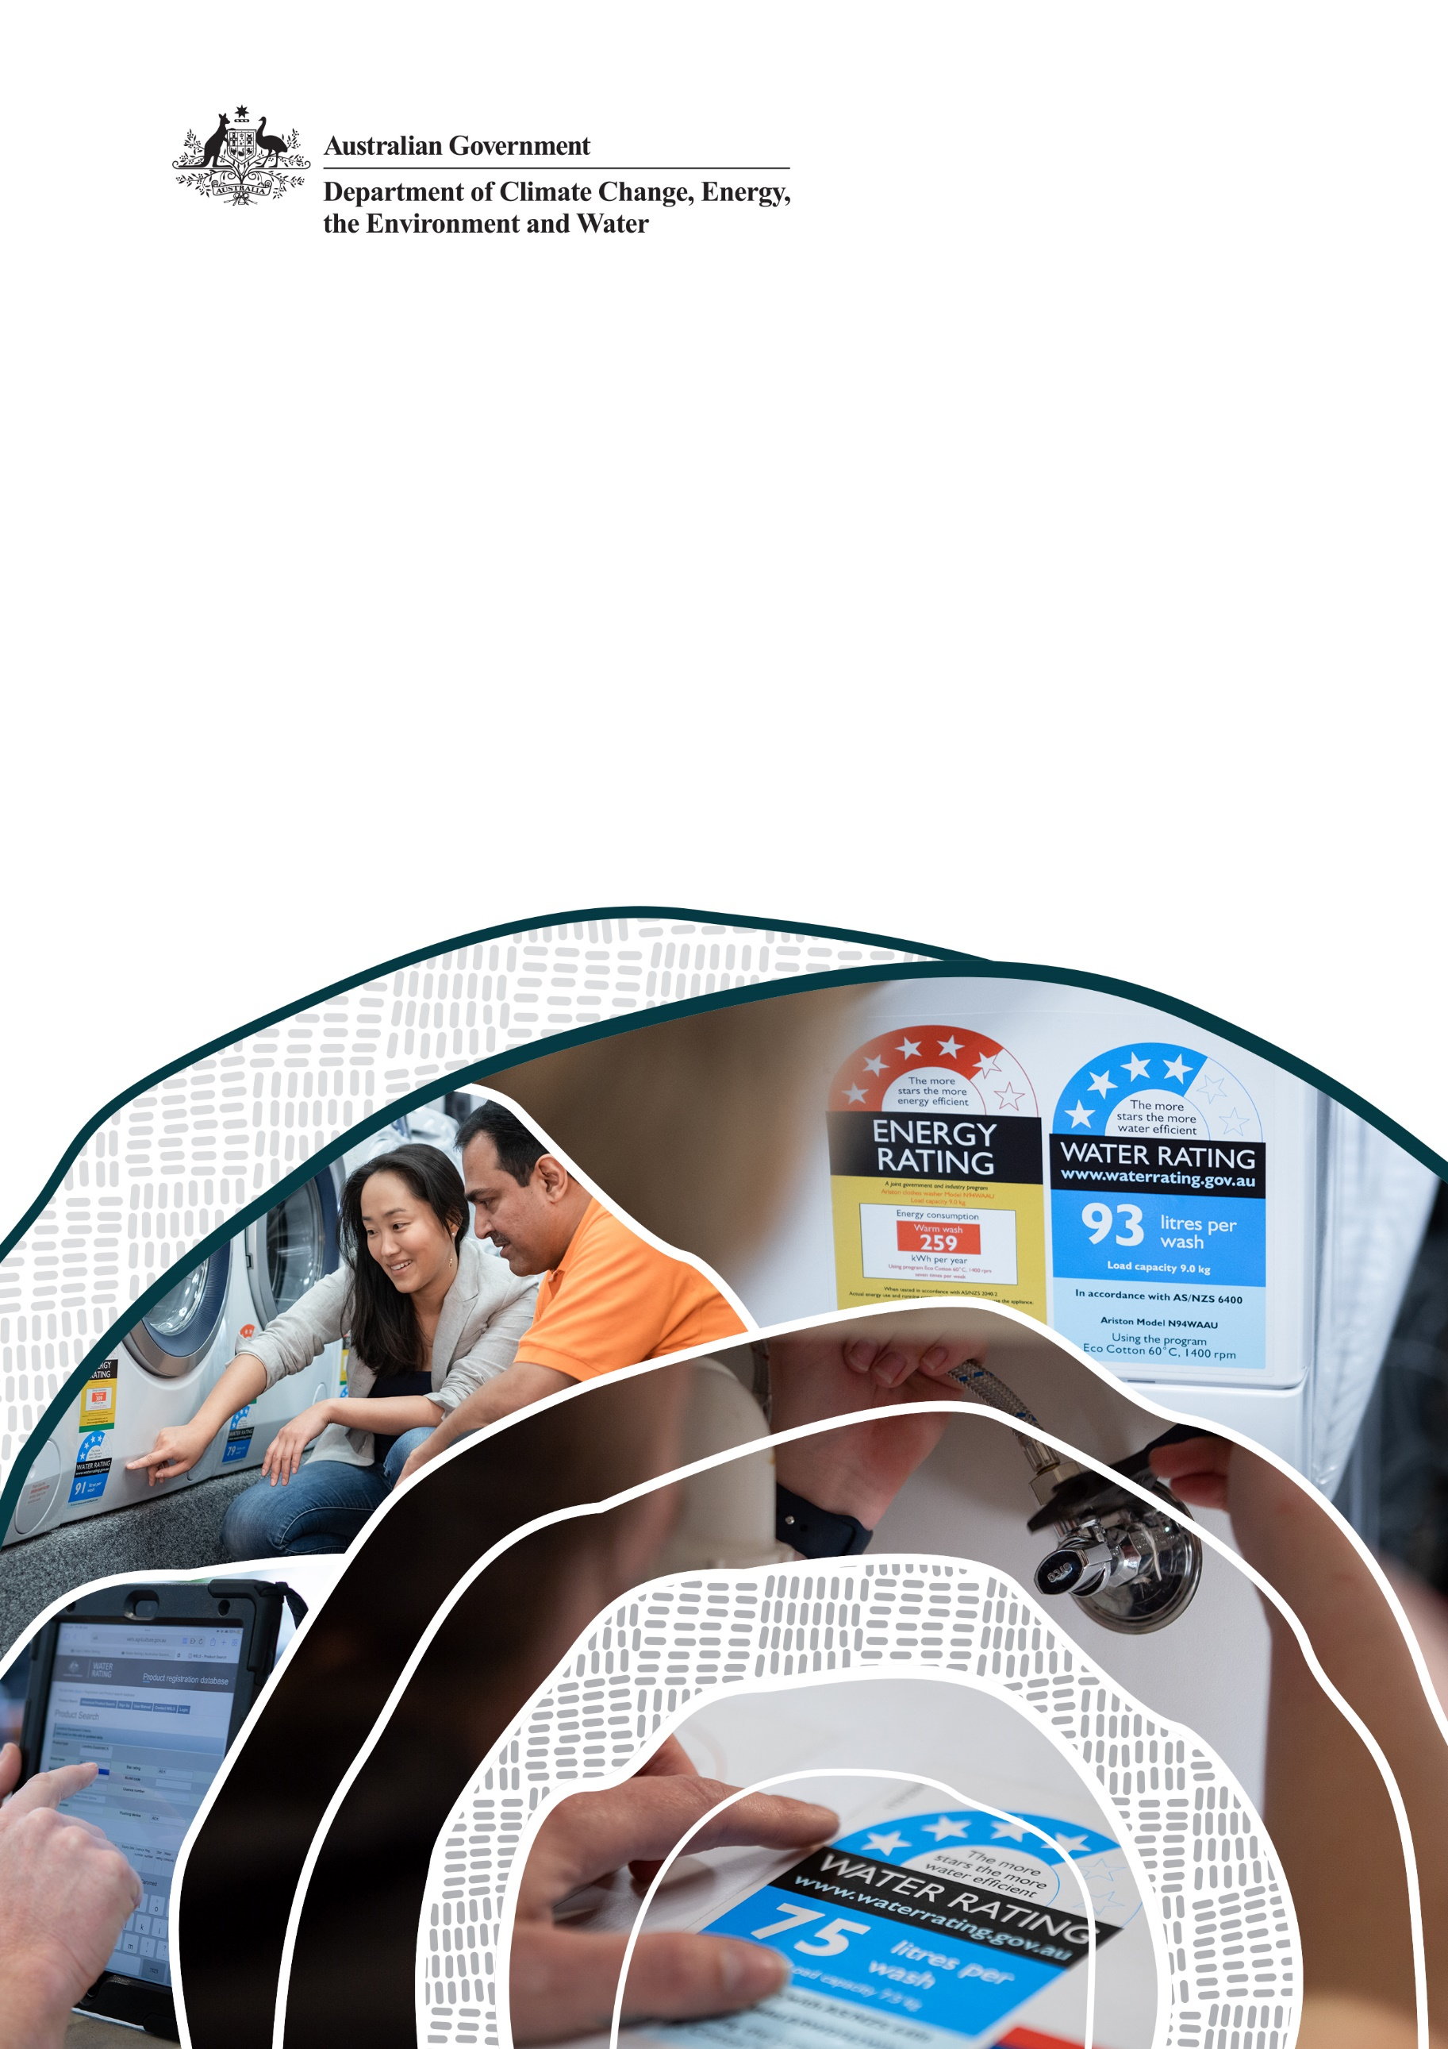
Water Efficiency Labelling and Standards scheme

Product Expansion Program

2024–25 Work plan
Department of Climate Change, Energy, the Environment and Water
22 July 2024

© Commonwealth of Australia 2024
Ownership of intellectual property rights
Unless otherwise noted, copyright (and any other intellectual property rights) in this publication is owned by the Commonwealth of Australia (referred to as the Commonwealth).
Creative Commons licence
All material in this publication is licensed under a Creative Commons Attribution 4.0 International Licence except content supplied by third parties, logos and the Commonwealth Coat of Arms.
Inquiries about the licence and any use of this document should be emailed to copyright@dcceew.gov.au.

Cataloguing data
This publication (and any material sourced from it) should be attributed as: DCCEEW 2024, Amendment to the Water Efficiency Labelling and Standards Determination 2013 (No. 2), Department of Climate Change, Energy, the Environment and Water, Canberra, July. CC BY 4.0.
This publication is available at www.waterrating.gov.au/register/new-product-category-nomination.
Department of Climate Change, Energy, the Environment and Water
GPO Box 3090 Canberra ACT 2601
Telephone 1800 920 528
Web dcceew.gov.au
Disclaimer
The Australian Government acting through the Department of Climate Change, Energy, the Environment and Water has exercised due care and skill in preparing and compiling the information and data in this publication. Notwithstanding, the Department of Climate Change, Energy, the Environment and Water, its employees and advisers disclaim all liability, including liability for negligence and for any loss, damage, injury, expense or cost incurred by any person as a result of accessing, using or relying on any of the information or data in this publication to the maximum extent permitted by law.
Acknowledgement of Country
We acknowledge the Traditional Owners of Country throughout Australia and recognise their continuing connection to land, waters and culture. We pay our respects to their Elders past and present.

Contents
Introduction 4
Background 4
1.1 WELS scheme 4
1.2 Product Expansion Program 4
1.3 Product Expansion Program cycle 4
Product categories nominated in 2024 6
1.4 Nominated product categories 6
Threshold tests and prioritisation assessments 7
1.5 Threshold test questions 7
1.6 Threshold test results 7
1.7 Prioritisation assessment criteria 8
1.8 Prioritisation assessment results 9
2024–25 Work plan 9
1.9 Preliminary and regulatory assessments 9
APPENDIX A Product statements 10
1.10 Commercial ice makers 10
1.11 Commercial clothes washing machines 10
1.12 Thermostatic mixing taps 11
1.13 Commercial water-cooled wok stoves 11

Introduction
This document reports on the product category nominations received for the Water Efficiency Labelling and Standards (WELS) scheme in 2024, the outcomes of their threshold tests and prioritisation assessments, and includes the Product Expansion Program Annual work plan
for 2024–25.

Background

WELS scheme
The Water Efficiency Labelling and Standards (WELS) scheme is Australia’s urban water saving scheme. It aims to reduce demand for drinking water by informing consumers about water efficiency at the point of sale. All Australian states and territories participate in the WELS scheme.
The scheme provides a national approach to applying a mandatory water efficiency star rating to plumbing products and appliances. Products within scope of the scheme are dishwashers, washing machines, washer-dryers and most taps, showers, toilets, urinals and flow controllers.

Product Expansion Program
The objective of the WELS scheme’s Product Expansion Program is to evaluate the benefits of regulating new and existing water-using or water-saving products. The program enables the WELS scheme to respond to:
- shifting product markets, industry innovation and stakeholder expectations
- Recommendation 2.1 of the 2020 Independent Review of the WELS scheme which stated: develop a framework which will prioritise a product range that is most likely to impact on the WELS scheme achieving its objectives in reducing water consumption.
To support an evidence-based evaluation process, a Product Assessment Framework was developed in 2023 in collaboration with industry and state and territory government representatives. The framework allows for potential WELS products to be evaluated in a staged approach, to determine if there is value in further pursuing their inclusion within the WELS scheme.
If there is a national cost-benefit for regulating an additional product category, it would require the agreement of the Australian Government Minister for the Environment and Water and a majority of state and territory government water ministers for its introduction. Careful consideration would be given to the implementation approach and timing, in consultation with industry.

Product Expansion Program cycle
The Product Expansion Program has an annual cycle.
The cycle involves seeking product nominations from stakeholders, performing threshold tests and prioritisation assessments of nominated products, development of an annual work plan, assessment of prioritised products and reporting of assessment outcomes. Figure 1 shows the stages in the annual cycle of the Product Expansion Program stages.
Figure 1 – Product Expansion Program cycle

Product categories nominated in 2024
Stakeholders were invited to nominate products from 5 February to 15 March 2024. Consultation and nominations were managed through the Department of Climate Change, Energy, the Environment and Water’s Have Your Say online survey platform.
The department promoted the opportunity to nominate products through a range of communication channels. An emphasis was placed on attempting to consult with ‘non-traditional‘ WELS entities whose products also use water in their operation. Communication activities are shown in Table 1.
Table 1 – Product nomination communication activities
Date | Description
5 February 2024 | Targeted email invitation to known stakeholders to nominate products and to share the invitation publicly with their networks.
5 February 2024 | Publishing of a New product category nomination page on the Water Rating website that explained how to nominate a product.
5 February – 15 March 2024 | Advertising the opportunity to nominate products on the Water Rating website (with a link to the Have Your Say online survey), coinciding with the release of the product nomination survey.
7 February 2024 | Administrators of the National Australian Built Environment Rating System (NABERS) posted the opportunity to nominate products to the WELS scheme on their social media platform.
29 February 2024 | Departmental media release issued advising of the opportunity to nominate products to the WELS scheme. The media release was sent out to 194 media contacts from 11 sectors, including: plumbing, manufacturing, manufacturing and industrial, manufacturing industry, water conservation, water resources, water/wastewater treatment, workplace safety and workers’ compensation, business, business statistics, and environment.
1 March 2024 | Departmental social media post for new product nominations was published on Twitter, LinkedIn, Facebook and Instagram.
6 March | The Australian Building Codes Board posted the opportunity to nominate products to the WELS scheme on their social media platform.

Nominated product categories
Six product categories were nominated by stakeholders and are listed in Table 2.
Two of the products were nominated by either the supplier of the product, or an industry group on behalf of a range of members, both representing direct industry interest in product regulation.
Remaining nominations were submitted by a consumer advocacy group and a water utility. These nominations were not driven by the manufacturer or supplier of the product and were nominated by entities that would not be regulated.

Table 2. Product category nominations received
Nominated product | Nominees | Date nominated
Heat pump hot water systems | Consumer advocacy group | 5 February 2024
Thermostatic mixing taps | Industry representative group | 5 February 2024
Hot water conservation appliance | Supplier | 16 February 2024
Commercial clothes washing machines | Water utility | 13 March 2024
Commercial water-cooled wok stoves | Water utility | 13 March 2024
Commercial ice makers | Water utility | 14 March 2024

Threshold tests and prioritisation assessments

Threshold test questions
All nominated products must pass a basic threshold test to be considered for prioritisation and preliminary assessment. Table 3 lists the seven questions that a product must pass.
Table 3. Threshold test questions
Question | Description
Question 1 | Does the product meet the WELS Act definition of ‘water-saving’ or ‘water-using’ product?
Question 2 | Is the product supplied or advertised for supply in Australia?
Question 3 | Is the product for either residential or commercial use?
Question 4 | Is the product a stand-alone item (i.e. not part of a system)?
Question 5 | The product does not act like a storage device, from which other products draw water?
Question 6 | Does the product consume water when in use (i.e. does it have a water flow rate)?
Question 7 | Is the product provided in a range of models?

Threshold test results
Two of nominated products failed the threshold assessment and will not be considered any further. Table 4 shows the outcome of the threshold test.

Table 4. Threshold test outcomes
Nominated product | Q1 | Q2 | Q3 | Q4 | Q5 | Q6 | Q7
Heat pump hot water systems |  |  |  |  | 
Thermostatic mixing taps
Hot water conservation appliance
Commercial clothes washing machines
Commercial water-cooled wok stoves
Commercial ice makers

Prioritisation assessment criteria
The prioritisation is used to determine the order that products that pass the threshold test will be assessed. Given that the WELS team has limited resourcing, prioritisation of nominated products is needed to ensure effort is initially directed to products that may deliver the greatest benefit.
Three broad criteria, containing several sub-criteria, are used to determine product prioritisation:
- potential water savings
  - product prevalence
  - geographical prevalence
  - product water consumption
  - frequency of use
  - user influence
  - product range and differentiation
- energy use (if relevant to the product)
  - direct or indirect energy consumption
  - product priority for the Greenhouse and Energy Minimum Standards Regulator
- ease of assessment
  - alignment with other schemes
  - stakeholder support
  - data availability
  - existing standards
  - ability to test
A weighted score between 1 and 3 is assigned against each sub-criteria, with an aggregate of the weighted scores being calculated. A higher weighting was applied to the potential water saving criteria.

Prioritisation assessment results
Prioritisation resulted in the ordering of product categories as listed in Table 5. Product statements that provide additional information about the products is provided at Appendix A.
Table 5. Prioritisation of nominated products
Prioritisation | Nominated product | Prioritisation score | Outcome
1 | Commercial ice makers | 2.62 | Proceed to preliminary assessment
2 | Commercial clothes washing machines | 2.54 | Proceed to preliminary assessment
3 | Thermostatic mixing taps | 2.37 | Proceed to regulatory evaluation
4 | Commercial water-cooled wok stoves | 2.03 | Proceed to preliminary assessment

2024–25 Work plan

Preliminary and regulatory assessments
During 2024–25, preliminary assessments will be undertaken for the two highest prioritised products – commercial ice makers and commercial clothes washing machines. Preliminary assessment will involve a more detailed evaluation of a product’s potential water saving, energy use and ease of assessment.
Thermostatic mixing taps (priority 3) do not need a preliminary assessment as the inclusion of ‘tap equipment’ has already been established as being within scope of the WELS scheme. The next step for thermostatic mixing taps is to understand if a regulatory impact assessment is required if they were to be included.

APPENDIX A Product statements
The following product statements provide a simple description of the product categories nominated and which will be further assessed.

Commercial ice makers
Commercial ice makers are used in a range of settings, where ice is directly used in, or in contact with, food or drink. These settings can include hospitality and service sectors, hotels, food displays, commercial kitchens, hospitals, laboratories, and grocery stores.
Commercial ice makers are available as either:
- water-cooled – where cold water is used to expel waste heat from the ice maker’s heat exchanger (with water often going to waste)
- air-cooled – where air (delivered by a motor driven fan) is used to expel waste heat from the ice maker’s heat exchanger.
According to the US Environmental Protection Agency WaterSense program, water-cooled ice makers use between 56L to 189L of water (excluding water for cooling purposes) to make 45kg of ice. This range depends on the amount of water used to rinse ice making surfaces of machinery and the amount of water needed for high quality ice. In total, including ice production and cooling processes, water-cooled ice machines with single pass cooling consume between 378 L to 1135 L of water per 45 kg of ice produced.

Commercial clothes washing machines
Commercial clothes washing machines are designed for use in commercial settings, rather than in domestic or industrial settings. Examples of where commercial washing machines are used include laundromats, residential aged care, childcare, healthcare facilities, hotels, student housing, prisons and caravan parks. Compared to domestic clothes washing machines, commercial machines contain higher-grade motors, pumps and heating elements, and are designed for constant use and large loads. They can also be configured to receive payment for operation.
Commercial clothes washing machines are commonly grouped with industrial washing machines, which cover the ‘non-domestic’ washing machine market. However, industrial clothes washing machines are larger, can be built-to-order, have a higher load capacity, and deliver a high level of sanitation. These machines have fewer wash programs but are equipped with more advanced controls and components for industrial grade washing. These products are not within scope of the product being considered.
Commercial washing machines tend to be smaller and have a lower load capacity than industrial washing machines. Commercial machines tend to be more customer facing and easier to use. Commercial clothes washing machines are designed to last 10 to 15 years.
Domestic clothes washing machines are regulated under the WELS scheme. Domestic clothes washing machines can also be used in commercial settings (e.g. childcare centres).

Thermostatic mixing taps
Thermostatic mixing taps (or thermostatically controlled taps) are defined as a tap into which hot and cold water entering through separate ports are mixed in a chamber and then delivered through a single common outlet. The temperature of the mixed water is automatically controlled at a user-adjustable temperature that is suitable for direct contact with the skin and which gives the user the ability to shut-off the outlet flow.
The valves within thermostatic mixing taps manage fluctuations in water temperatures caused by variations in pressure and temperature of the cold and hot water supply. When adjusted to temperatures not exceeding 45°C, thermostatic mixing taps are intended for use in health care, aged care, childcare and disability settings. Where the temperature does not exceed 50°C, these thermostatic mixing taps can be used for other applications.
Tap equipment that is for use exclusively over a fixed basin, sink or laundry tub is regulated under the WELS scheme. When the scheme was implemented in 2005, thermostatic mixing taps were excluded from the scheme as the technology for delivering a reduced flow while maintaining the required temperature did not exist. This technology now exists to enable these taps to meet performance standards, with the National Construction Code requiring these taps to meet minimum water efficiency required of all other taps.

Commercial water-cooled wok stoves
Wok stoves are commonly used in commercial kitchens for Asian/mixed cuisine food preparation and sales, with gas burners being the most common form of heating.
Commercial woks are often stand-alone appliances in single, double or triple stands. They require very high heat and models that are water-cooled require a constant flow of water to remove excessive heat from the cooktop and surrounds.
There are two waterless commercial wok stove options (excluding water used for cleaning). These are air-cooled and induction wok stoves. Induction woks also remove the need for gas for cooking, resulting in significant greenhouse gas savings and cost reductions. There is no additional cooling required for induction wok cooking.

