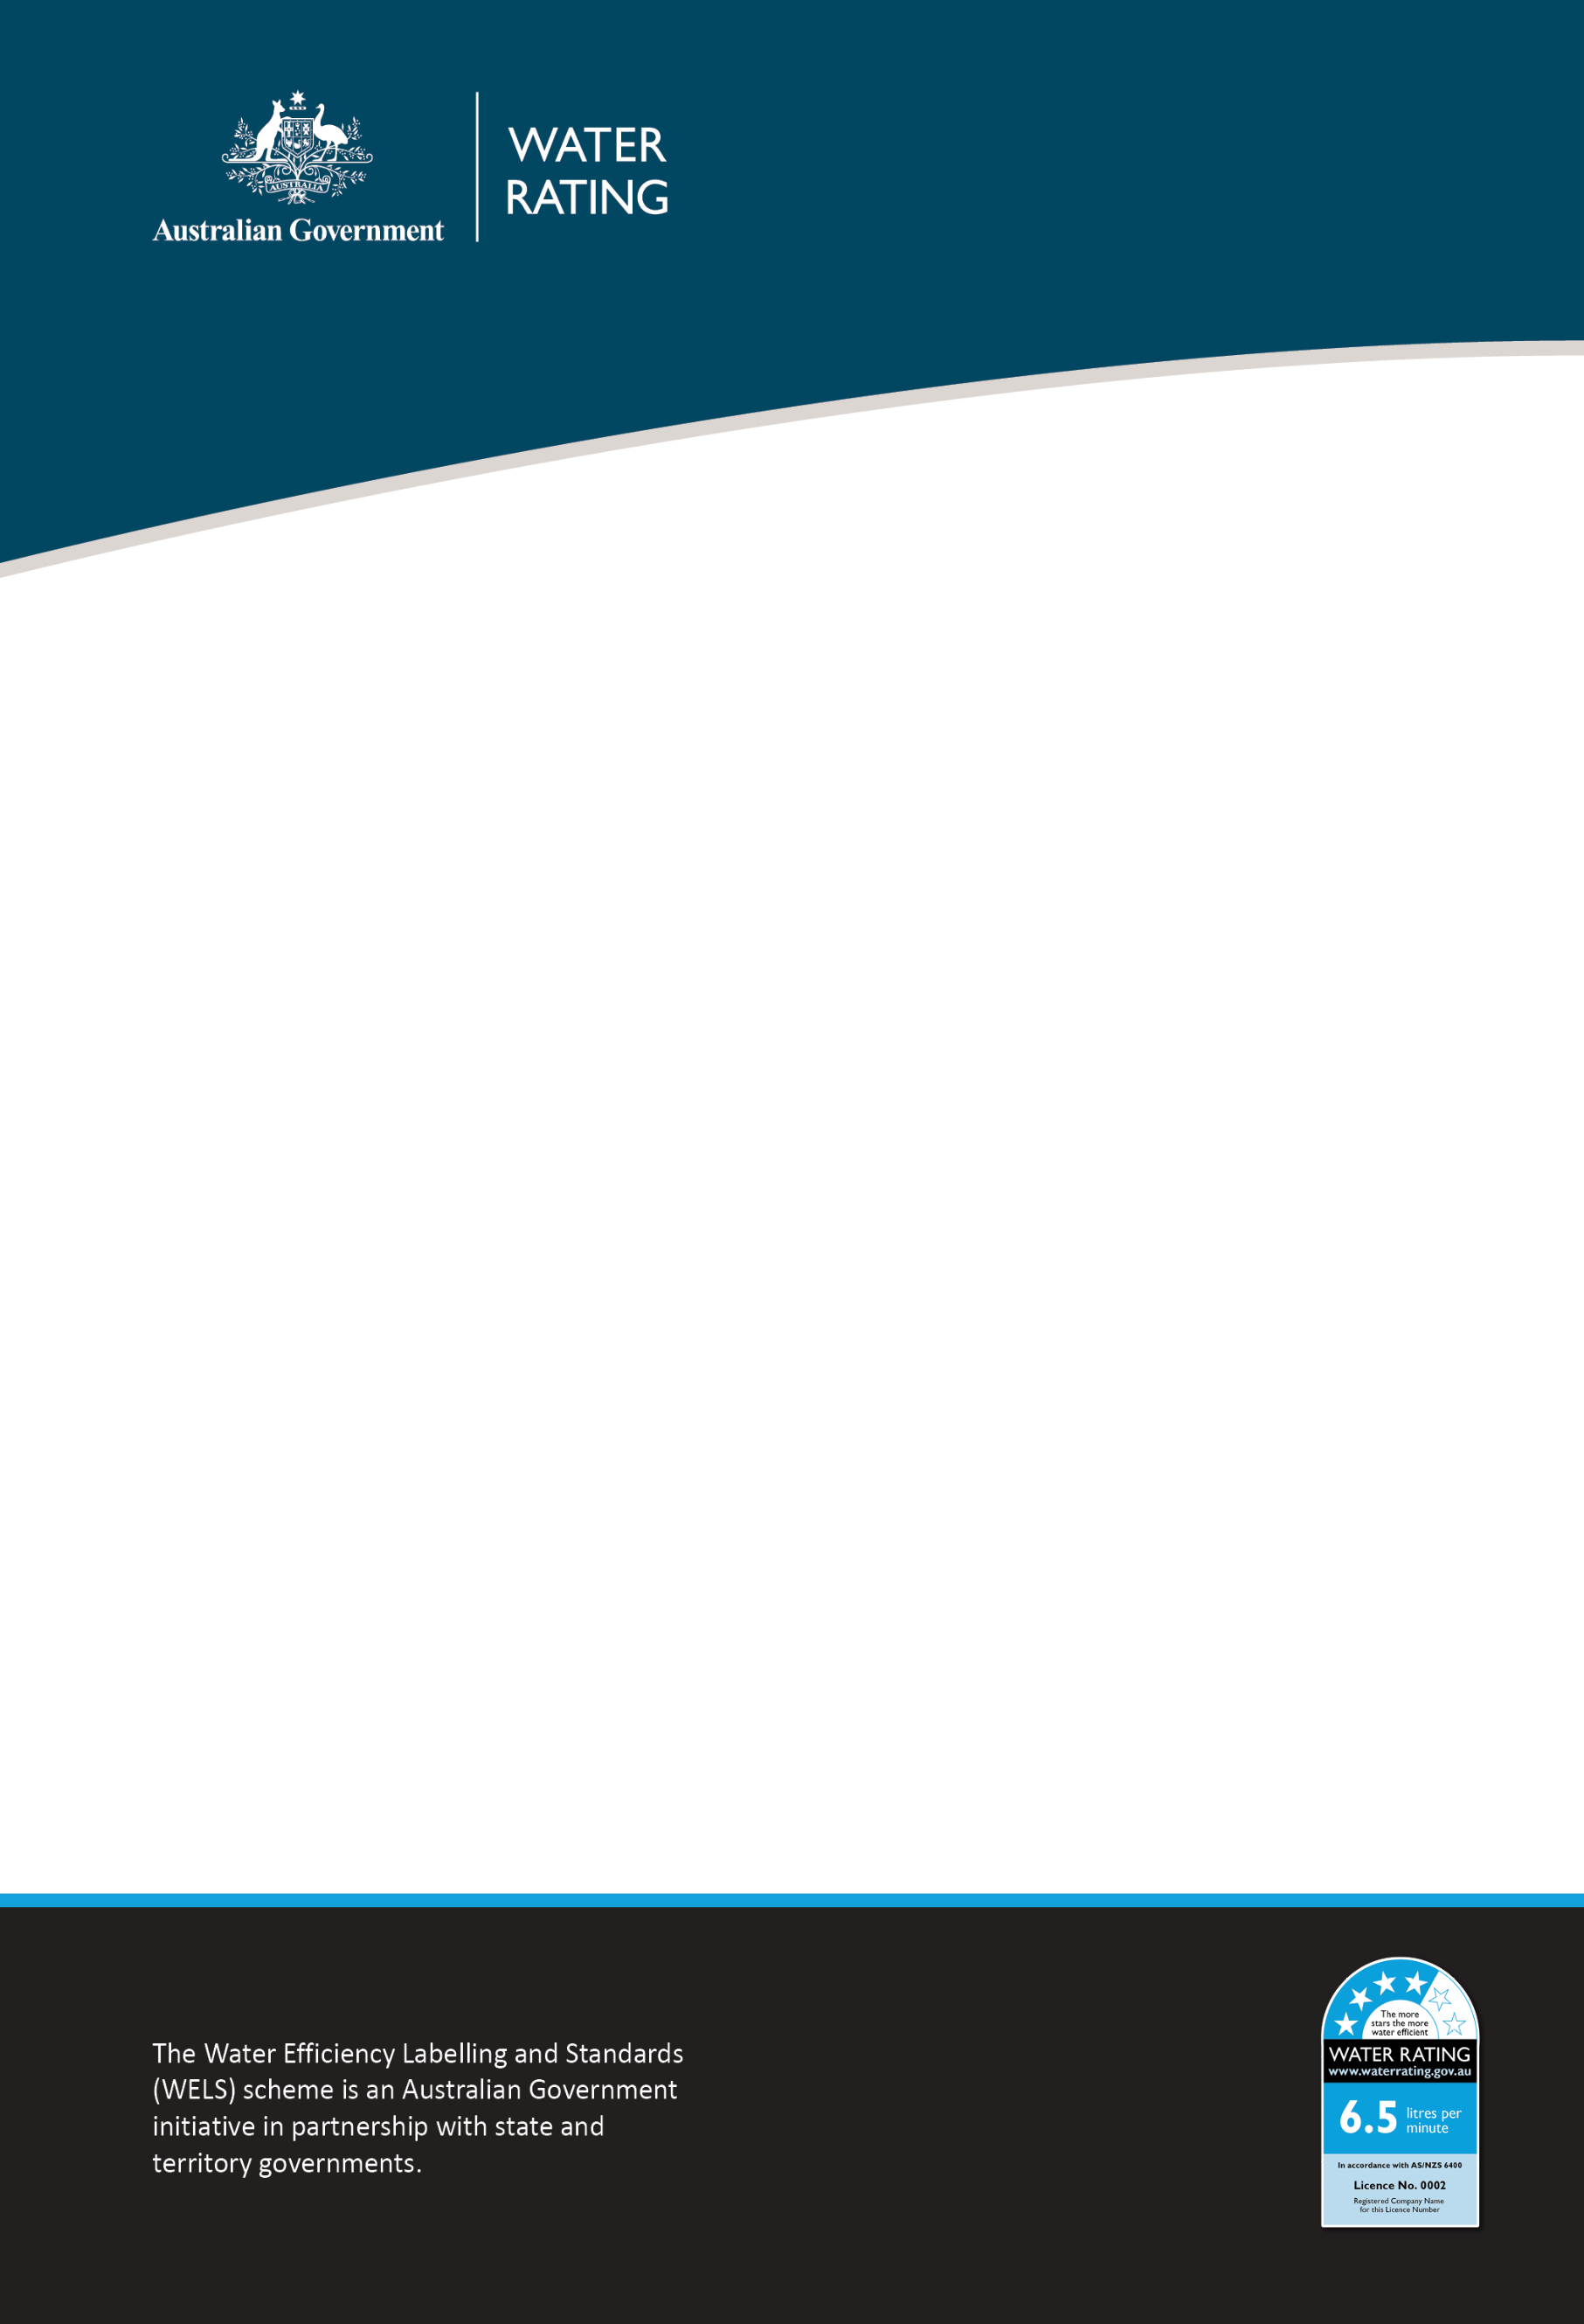

WELS 3D Flow Controller animation transcript

Inside all modern taps and showers there is a small but important device called a flow controller.

Flow controllers are regulated under the Water Efficiency Labelling and Standards scheme and promote more efficient water use in showers and taps.

They are the main component that reduce the high water flows down to as little as 5 litres per minute.

Sometimes customers ask their plumbers to remove the flow controller, thinking it will make the tap or shower better.

But it doesn’t.

If it’s removed, the tap or shower will no longer function as it was designed and use a lot more water.

Making your shower or tap not work as it was intended.

And lead to much larger water bills.

The WELS scheme will save 172 gigalitres of water for Australia in 2024. That's equal to filling 109 Melbourne Cricket Grounds with water and saving $1.6 billion in utility bills.
So, leave flow controllers in place, to keep saving water, energy and money.

