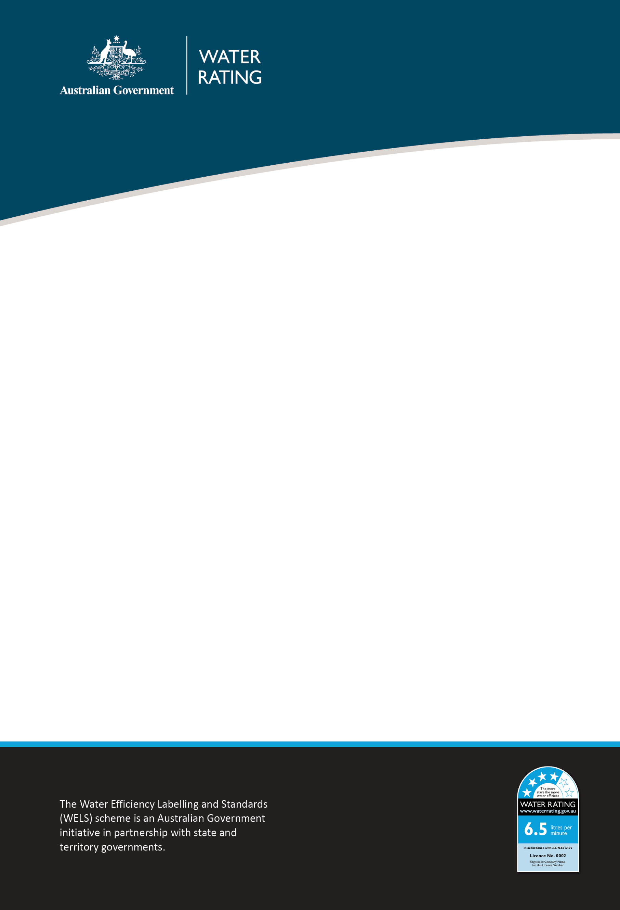

WELS Compliance Plan 2024–25

Purpose
This document outlines where the Water Efficiency Labelling and Standards (WELS) Regulator will direct effort to ensure the regulatory integrity of the WELS scheme. We may adjust this in response to new intelligence and emerging regulatory priorities and risks.
This document should be read in conjunction with the WELS Compliance and Enforcement Policy.

Our risk-based compliance focus in 2024–25
We will monitor compliance in the following areas:
Area of non-compliance | Activity
Supply of unregistered WELS products | - Onsite inspections of retail outlets  - Inspections of building developments  - Monitor online advertising of WELS products  - Work with co-regulators and e-commerce administrators to enhance detection capabilities and responses of online marketplaces  - Education of plumbers and builders
Fraud | - Detection of regulated products offered for supply that claim to be WELS registered  - Improvement of intelligence analytics capability  - Detection of fraudulent documentation through product registration assessments  - Education of registrants
Non-compliant labelling and text advice | - Conduct onsite inspections of retail outlets  - Monitor online advertising of WELS products
Inaccurate or incorrect documentation and information in product registration applications and registration renewal | - Assessment and validation of documents and information provided in product registration applications  - Random auditing of documents and information for product registration renewal applications  - Education of registrants

Our approach to compliance
In addition to our focus areas, we will continue to:
- respond to allegations of non-compliance
- actively work with industry to promote awareness of and compliance with requirements
- monitor suppliers of WELS-regulated products
- detect and respond to non-compliance.
We will work with individuals and businesses to encourage and support voluntary compliance by providing education and advice.
Where non-compliance is detected, we assess this against legislative requirements and use a risk-based approach to determine an appropriate and proportionate response. We have a range of options to escalate our response, including the use of civil and enforcement provisions, if necessary.
To learn more, please read the WELS Compliance and Enforcement Policy.

Contact

WELS Compliance Team
1800 372 746 (within Australia) +61 2 5162 1815 (international)
welscompliance@dcceew.gov.au.

Registrations team
1800 218 478 (within Australia) +61 2 5162 1816 (international)
wels@dcceew.gov.au.

