# Water Efficiency Labelling and Standards scheme Compliance and Enforcement Policy

# 2022

© Commonwealth of Australia 2022

**Ownership of intellectual property rights**

Unless otherwise noted, copyright (and any other intellectual property rights) in this publication is owned by the Commonwealth of Australia (referred to as the Commonwealth).

**Creative Commons licence**

All material in this publication is licensed under a Creative Commons Attribution 4.0 International Licence except content supplied by third parties, logos, and the Commonwealth Coat of Arms.

Inquiries about the licence and any use of this document should be emailed to [copyright@dcceew.gov.au](mailto:copyright@dcceew.gov.au)



**Cataloguing data**

This publication (and any material sourced from it) should be attributed as: Water Efficiency Labelling and Standards Regulator 2022, *Water Efficiency Labelling and Standards Scheme Compliance and enforcement Policy*, Department of Climate Change, Energy, the Environment and Water

This publication is available at waterrating.gov.au/enforce/our-approach

Department of Climate Change, Energy, the Environment and Water

GPO Box 3090 Canberra ACT 2601

Telephone 1800 372 746

Website www.dcceew.gov.au

**Disclaimer**

The Australian Government acting through the Department of Climate Change, Energy, the Environment and Water has exercised due care and skill in preparing and compiling the information and data in this publication. Notwithstanding, the Department of Climate Change, Energy, the Environment and Water, its employees and advisers disclaim all liability, including liability for negligence and for any loss, damage, injury, expense, or cost incurred by any person as a result of accessing, using or relying on any of the information or data in this publication to the maximum extent permitted by law.

**Acknowledgement of Country**

Our department recognises the First Peoples of this nation and their ongoing connection to culture and country. We acknowledge First Nations Peoples as the Traditional Owners, Custodians and Lore Keepers of the world's oldest living culture and pay respects to their Elders past, present and emerging.

Contents

1 Purpose of this policy 1

2 Introduction 1

2.1 WELS scheme Purpose 1

2.2 Products we regulate 1

3 Regulatory context 2

3.1 Legislation 2

3.2 Australian Standards 2

3.3 International Standard 3

3.4 Related programs 3

4 Compliance and enforcement objectives and principles 3

4.1 Objectives 4

4.2 Principles 4

5 Our approach to regulation 5

5.1 Risk-based regulation 5

5.2 WELS regulatory response model 7

5.3 Communication and education 8

5.4 Monitoring compliance 8

5.5 Responding to non-compliance – administrative actions 9

5.6 Responding to non-compliance – enforcement actions 9

6 Information disclosure 10

7 Contact us 11

**Figures**

Figure 1 Products we regulate 1

Figure 2 Determining impact of non-compliance 5

Figure 3 Determining likelihood of non-compliance and culpability 6

Figure 4 WELS regulatory response model 7

## Purpose of this policy

This policy sets out the Water Efficiency Labelling and Standards (WELS) Regulator’s approach to performing regulatory functions and exercising powers under the WELS scheme.

This policy outlines our compliance objectives and response measures to non-compliance and provides transparency in the way we regulate the scheme.

## Introduction

### WELS scheme Purpose

The WELS scheme is a partnership between the Australian Government, state and territory governments and industry.

​​​​​The WELS scheme is Australia's urban water saving scheme. The scheme reduces demand for water by informing consumers about the water efficiency of fittings and appliances at the point of sale.

The scheme helps consumers choose products that can reduce their water use, save money on water and energy bills, and improve national water security and reliability.

In 2023, the scheme is expected to save:

* 165.2 GL of water across Australia. This is equivalent to 66,080 Olympic-size swimming pools and more than 17 litres per person per day[1].
* $1.541 Billion in reduced utility bills. That is roughly $143 per household[2] per year.

### Products we regulate

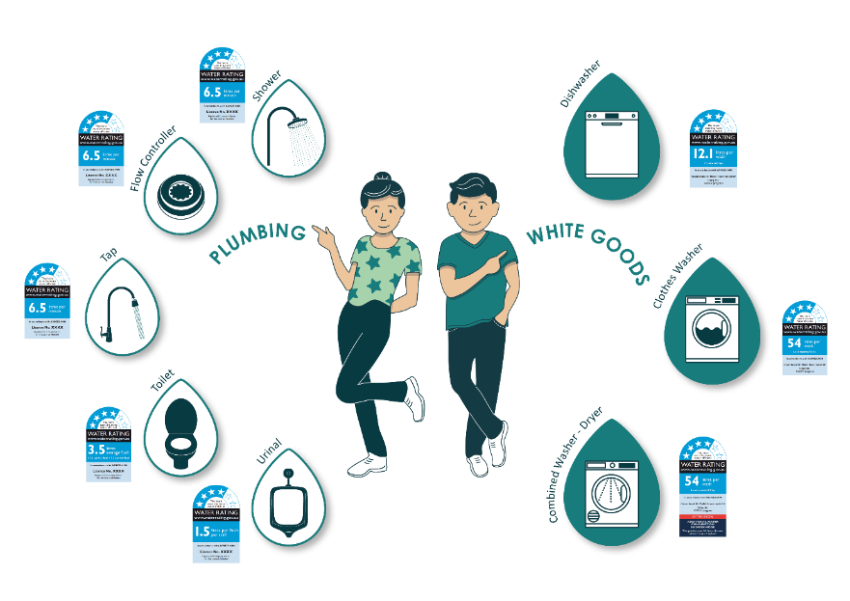

Regulated products are required to meet Australian Standards for water efficiency and must be registered and labelled with their water rating information when supplied. Under the section 7A of the *Water Efficiency Labelling and Standards Act 2005* (Cth) (WELS Act), supply includes advertising, displaying in stores and online, selling, gifting, re‑supplying, exchanging, and supplying as part of another thing.

All parts of the supply chain, from manufacturers through to retailers and installers, have an obligation to ensure products offered for sale in Australia are registered and labelled correctly. This ensures consumers can make an informed choice about their purchases based on the water efficiency of the products.

Learn more about the scheme on the [waterrating.gov.au](https://www.waterrating.gov.au/).

## Regulatory context

### Legislation

The scheme was established in 2005 under WELS Act. The objects of the WELS Act are:

* to conserve water supplies by reducing water consumption
* to provide information for purchasers of water-use and water-saving products
* to promote the adoption of efficient and effective water-use and water-saving technologies.

The WELS Act is supported by delegated Commonwealth legislation and by complementary legislation enacted in all states and territories.

Delegated Commonwealth legislation includes:

* Water Efficiency Labelling and Standards Regulations 2005
* Water Efficiency Labelling and Standards Determination 2013 (No. 2)
* Water Efficiency Labelling and Standards (Registration Fees) Act 2013
* Water Efficiency Labelling and Standards (Registration Fees) Determination 2013.

### Australian and New Zealand Standards

The WELS Act establishes the WELS Standard which sets out the technical basis for rating water efficiency and performance in specified products and for labelling and registration.

The WELS Standard is AS/NZS 6400:2016 Water efficient products – Rating and labelling.

The WELS Standard is linked to other product standards such as AS/NZS 3662:2013 Performance of showers for bathing and to the Plumbing Code of Australia (the Plumbing Code), which is a part of the National Construction Code.

The Plumbing Code sets the requirements for the design, construction and maintenance of plumbing and drainage systems in new and existing buildings. The code covers WELS plumbing products when they are intended for use in a plumbing and drainage system.

For a full list of documents referenced in the WELS Standard, see subsection 1.5 of the Standard.

### International Standard

The international standard ISO 31600:2022 – *Water efficiency labelling programmes – Requirements with guidance for implementation* provides a framework of requirements for the development of a water efficiency labelling program.

The WELS scheme meets the requirements of ISO 31600:2022 and is recognised in the standard as a well-established and effective water efficiency labelling program.

### Related regulatory programs

The scheme interacts with other national and state regulatory schemes. We understand our roles and relationships. Where possible, we harness opportunities to achieve mutual outcomes for the objectives of coregulators and to streamline requirements for the regulated community.

In administering the scheme, we work with state and territory co-regulators, the Commonwealth WaterMark and Equipment Energy Efficiency (E3) program administrators, the New Zealand Government, e-commerce platform providers, industry members and associations, consumer organisations and regulated entities. The regulated business sectors include product registrants, manufacturers, importers, and suppliers – including on-line sellers, retailers, wholesalers, builders, plumbers, and developers.

#### E3 program

The E3 program is administered by the Department Climate Change, Energy, the Environment and Water. The E3 program is underpinned by the Greenhouse and Energy Minimum Standards Act 2012, which is administered by the GEMS Regulator.

Clothes washing machines and dishwashers regulated under the WELS scheme must be registered by the GEMS Regulator and comply with relevant energy labelling requirements.

Further information is available at: www.energyrating.gov.au

#### WaterMark

The WaterMark scheme is administered by the Australian Building Codes Board. Plumbing products regulated under the WELS scheme must have valid WaterMark certification for installation in a plumbing and drainage system. State and Territory building regulations enforce the minimum water efficiency of products installed, except in Queensland where WaterMark is enforced at point of sale.

Further information is available at: watermark.abcb.gov.au

## Compliance and enforcement objectives and principles

Compliance with the scheme is critical for reducing the demand on our water resources and building confidence in the regulatory effectiveness of the WELS label and the scheme. It ensures consumers, businesses and governments are fulfilling their obligations in the practice of sustainable water management.

We aim to ensure that only WELS registered products are available to consumers at the point of sale, so that:

* consumers can make an informed choice relating to the water efficiency of the products they purchase
* consumers are encouraged to or are required to consider more efficient products
* consumers can reduce water use and save money on water and energy bills
* consumers and builders can meet state and territory regulatory minimum water efficiency requirements for plumbing installation and under tenancy laws
* water demand management programs of governments and utilities that rely on swapping or upgrading to more water efficient products are enabled
* water efficiency targets in sustainable building rating schemes can be met by sourcing rated products.

### Objectives

The WELS compliance and enforcement objectives are to:

* engage, communicate, and educate product registrants, manufacturers and suppliers on the WELS requirements under Australian law
* work with Commonwealth and state and territory coregulators to support the scheme and related programs
* ensure product registration compliance through the registration system and processes
* monitor compliance and detect non-compliance
* support voluntary compliance and positive actions to remedy inadvertent minor non‑compliance
* respond to non-compliance through audit and investigation
* use escalated response measures and enforcement powers to correct repeated and serious non-compliance.

### Principles

The WELS Regulator compliance and enforcement functions will be undertaken in accordance with the following principles:

* **Targeted** – our compliance activities will focus on those entities who pose the greatest risk to achieving the scheme’s objectives.
* **Proportionate** - our response and enforcement actions will be evidence-based and applied proportionately to the seriousness of alleged or suspected non-compliance, culpability, and risk of harm to the community and water security.
* **Transparent** – we work with the regulated community and provide clear education on how to comply. We report internally and externally on our activities to support transparency of decisions. We publicise enforcement outcomes, as appropriate.
* **Fair and ethical** – we will undertake our compliance activities with integrity, professionalism and that allows for procedural fairness. Our staff will behave in accordance with the Australian Public Service (APS) Code of Conduct, APS Values and administrative law.
* **Collaborative** – we will work with other regulators and government agencies to share information and findings and collaborate on monitoring and compliance functions that will achieve efficient and effective whole-of-government outcomes.

## Our approach to regulation

Our approach to regulation is to monitor and support compliant behaviour and respond to suspected or actual non-compliance. We acknowledge that most regulated entities accept the obligations imposed on them by legislation and comply voluntarily. We will work with entities to provide additional support for them to understand their obligations and to ensure ongoing compliance. Where non-compliance cannot be resolved cooperatively, we will use the full force of civil and criminal law to achieve compliance and prevent non-compliant behaviour.

Our *proactive* compliance activities will prioritise those entities who pose the greatest risk to the scheme achieving its objectives, as well as those operators who have a history of non‑compliance. We engage with industry, government and the public to remain alert to emerging risks to the scheme through changes in the operating environment, product design, and methods of illegal trade. We leverage data and information sharing with State and Territory coregulators to identify emerging areas of compliance risk and engage proactively with entities to support compliance.

When we undertake proactive compliance monitoring, we consult other regulators and governments to improve efficiency and reduce duplication. We will work with others to support corrective actions in a proportionate way.

For our *reactive* compliance activities, we consider the nature of allegation, the potential for systemic issues, patterns of behaviour and whether more impactful outcomes can be achieved through corrective action via other programs and schemes.

### Risk-based regulation

The key aspects we consider in our risk-based approach to regulation are:

* impact from non-compliance
* likelihood of non-compliance and culpability
* reputational harm to the WELS scheme and the Australian Government

#### Determining the impact from non-compliance

To determine the impact from non-compliance we consider actual or potential impacts on water saving, consumers; and regulated product integrity. We also consider scale, duration, types of products, and the degree of misinformation or non‑compliance with the water efficiency and performance standards.

#### Determining the likelihood of non-compliance and culpability

To determine likelihood of non-compliance and culpability we consider entity compliance history, any business processes that are in place to prevent non-compliance, the entity’s behaviour when engaging with WELS Regulator and the scheme, and theirs role in the supply chain.

Entities that knowingly fail to meet regulatory obligations have higher culpability. Registrants are one such group of regulated entities who have reasonable awareness of their obligations under the scheme, in addition to others with past non-compliance history, and where we would view non‑compliance as deliberate.

#### Determining reputational damage from non-compliance

We value our reputation and what the WELS scheme delivers to consumers, industry and national water security.

In addition to the impact of non-compliance and culpability, the Regulator will also consider reputational damage to the WELS scheme and the Australian Government.

We strive to maintain our positive influence and support from co-regulators, industry and consumers in achieving our objectives. In deciding on our response to non-compliance, we will consider the damage caused by non-compliance to the WELS scheme reputation, industry and public confidence in the WELS label and perception of WELS program integrity.

We also recognise that the scheme arose from water saving initiatives of the Australian industry and water utilities, such that harm to the scheme could also negatively affect the industry. By regulating, we want to ensure a level playing field and that all industry participants pay their fair share of scheme costs.

### WELS regulatory response model

We uphold the integrity of the WELS label by ensuring that products are registered in accordance with requirements and non‑compliant products are not supplied to the Australian market.

We aim to work with industry to achieve compliance and support businesses in maintaining their reputation among consumers as trusted suppliers of WELS products.

We respond to non-compliance in a proportionate way. Our response to non-compliance takes into consideration the impact of non-compliance, culpability, and reputational damage to the scheme from the non-compliance.

We have a range of tools available to us to address non-compliance, from education through to full enforcement.

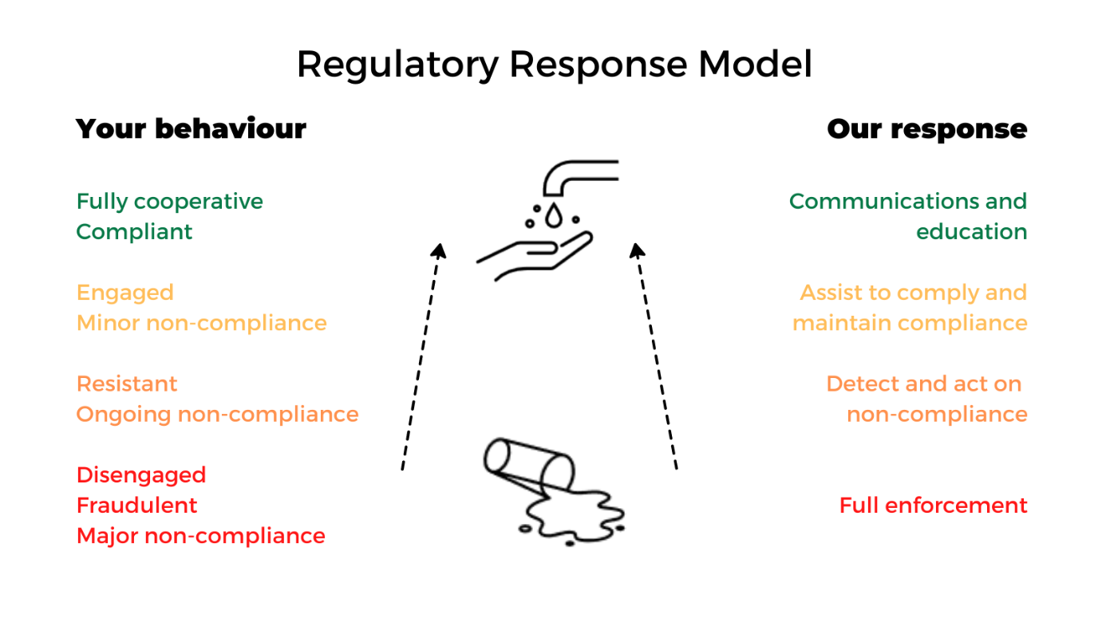

### Communication and education

We recognise that providing advice and education is the key to helping entities to voluntarily comply and to prevent inadvertent non-compliance.

We regularly publish information such as fact sheets and newsletters, conduct presentations and answer enquiries to assist industry in understanding and meeting their regulatory obligations under the WELS Act.

We engage and support compliance through a variety of communication channels, including meetings of the WELS Advisory Group, the WELS Officials Group, meetings with peak industry bodies, our coregulators, public surveys and consultations, advertising to consumers, attendance at trade shows, home expos, ad-hoc industry fora and through proactive inspections.

Industry members are engaged through codesign of the Australian and New Zealand WELS Standard, ensuring that the regulated industries understand and are able to meet the requirements.

We provide information and education through our online resources, such as

* the [WELS Water Rating website](https://www.waterrating.gov.au/about/contact),
* InkWELS newsletters (email [wels@dcceew.gov.au](mailto:wels@dcceew.gov.au) to subscribe),
* webinars and fact sheets (also available in Chinese Simplified and can be requested from [welscompliance@dcceew.gov.au](mailto:welscompliance@dcceew.gov.au)),
* answering queries through WELS information telephone lines and email inboxes (refer to Section 7 of this document ‘Contact Us’)
* supporting e-commerce providers to educate their sellers about WELS requirements.

### Monitoring compliance

We collect, monitor and analyse data and information to verify compliance and to detect potential non-compliance. We work with federal co-regulators and state and territory governments to share information and support compliance activities. We also have relationships with industry and supply chain enablers that support our efforts to monitor and achieve compliance.

We aim to detect non-compliance before it escalates or becomes ongoing. Where we suspect non-compliance, we may undertake additional targeted information or data collection to determine if there is actual non-compliance. We may undertake inspections and initiate audits to gather additional information, among other sources.

Inspectors, appointed by the WELS Regulator under the WELS Act, may use a range of powers set out under Part 9 of the WELS Act to monitor compliance and investigate non‑compliance. Inspector powers relate to entering premises, inspecting WELS products and their associated written information and advertising, and the collection of evidentiary material. Inspectors can also issue warnings and infringements for non-compliance. We aim to work with entities with their consent, however the WELS Regulator may also issue notices to confirm compliance and directions to achieve compliance.

### Responding to non-compliance – administrative actions

Generally, we attempt to cooperatively resolve potential breaches that are low-impact and low‑level culpability. We contact regulated entities to educate them of their compliance obligations and support compliance. We make initial contact via phone call and follow up with an email summarising any agreed actions and agreed timeframes.

If there is no response to our initial contacts or the response is unsatisfactory, we may issue a warning letter requiring action to rectify the non-compliance. Warning letters may be emailed and/or posted, and usually contain evidence of the alleged non-compliance.

If non-compliance is identified in relation to registered products, depending on the nature of non-compliance – the Regulator may suspend or cancel registrations. In certain circumstances, the Regulator may also refuse registration applications.

For suppliers of WELS products using e-commerce platforms, we will communicate primarily via platform messaging systems where available. The non-compliant sellers will be given time to correct any non-compliance and to communicate with the WELS Regulator about their circumstances.

When non-compliance remains unresolved after a specified period, the WELS Regulator, in collaboration with the e-commerce provider, will consider escalated actions. Depending on the scale of the non-compliance and the significance, product listings may be removed and a seller’s account on the platform may be restricted. The WELS Regulator may also issue a warning letter.

The e-commerce provider may apply their own measures to manage non‑compliance in addition to the WELS Regulator’s sanctions. For example, if a seller breaches e‑commerce platform policies, a seller’s account may be restricted or disabled.

For ongoing or major noncompliance, the WELS Regulator may escalate to enforcement actions, without using administrative measures first. This supports our holistic approach to managing compliance, including where non-compliant sellers create new accounts to continue non-compliant trading.

### Responding to non-compliance – enforcement actions

Enforcement may be necessary for a range of reasons including disrupting ongoing non-compliant behaviour, minimising harm being caused by serious non-compliance, protecting the integrity of the scheme, and to deter future non-compliance.

We may escalate to enforcement actions where our initial administrative action did not achieve compliance. Depending on the seriousness of the breach and culpability of the regulated entity, we may use enforcement measures to bring about compliance.

Broad and thematic non‑compliance activity that poses reputational risks to the scheme, the government and to industry may require resolution via court action and to serve as a deterrent. The WELS Regulator has the power to publicise contraventions of the WELS Act and such information will be made public.

Part 8 of the WELS Act sets out the range of enforcement options. The Criminal Code also applies to all strict liability offences against the WELS Act. These are offences that a person can be found guilty of even if they did not intend to commit them. This means that in criminal proceedings, the prosecution does not need to prove that the accused sought to commit a crime – only that a crime was, in fact, committed.. The Regulator will work with the Commonwealth Director of Public Prosecutions on any criminal matters.

In deciding which enforcement action to take, we apply a risk-based and proportionate approach. We consider a range of factors. We evaluate potential breaches and conduct investigations in accordance with the Australian Government Investigations Standards (AGIS).

The Regulator may apply one of the following enforcement measures:

* **compliance audit** – a notice requiring a person to undertake an audit to confirm their compliance with the WELS Act and to provide a written report setting out the results of the audit
* **remedial action** – a notice requiring a person to take action to remedy non‑compliant behaviour or prevent it in the future
* **infringement** – a notice requiring a person to pay a penalty for a breach as an alternative to prosecution or a civil penalty order issued through a court. Refer to the WELS [Infringement Notice Statement](https://www.waterrating.gov.au/enforce/penalties/infringement-notice-statement) for more information.
* **enforceable undertaking** – a written legally binding agreement by a person to take actions to correct their non-compliance and to stop future non-compliance
* **injunction** – a court order stopping an entity from taking action or requiring a person to take action
* **civil penalty** – a court order to pay the Commonwealth, as a result of civil proceedings
* **criminal prosecution** – a legal action in respect to a person that could result in imprisonment for a committed crime.

## Information disclosure

Information we receive from the public about alleged non-compliance will be handled in a confidential manner. Your personal information will be used and stored in accordance with the Australian Privacy Principles.

When required, we may disclose personal and other information held by us to other Australian government agencies, persons, or organisations, provided the disclosure is consistent with relevant laws, in particular the Privacy Act 1988 (Cth).

The WELS Regulator will not release detailed information about compliance and enforcement activities, such as current and ongoing investigations, unless it is required by law or by the investigative process. Summary information about compliance case work that does not identify the entities involved will be published as part of the WELS scheme Annual Report.

Where we choose to release information to support our regulatory outcomes, we will do so in accordance with our legal obligations. Division 2 of WELS Act allows the WELS Regulator to publicise a conviction for an offence against the WELS Act.

We will ensure that any released information does not prejudice a person’s right to a fair hearing or legal process or impinge upon the safety of others involved in the investigation (such as complainants, witnesses, and suspects) or prejudice any of our past or future activities.

Requests for information, including from regulated entities, may be made under the Freedom of Information Act 1982. For details about how to make a Freedom of Information (FOI) request, see [Freedom of Information](https://www.dcceew.gov.au/about/reporting/freedom-of-information#:~:text=The%20Freedom%20of%20Information%20Act,access%20the%20information%20another%20way.). Each FOI request will be considered on a case-by-case basis.

## Contact us

For more information on our approach to compliance and enforcement, or to report suspected non-compliance:

* visit our Water Rating website waterrating.gov.au.
* email welscompliance@dcceew.gov.au
* Toll-free call WELS Compliance on 1800 372 746 (International +61 2 6272 5232).

For more information on registrations:

* email wels@dcceew.gov.au
* Toll-free call WELS Registrations on 1800 372 746 (International +61 2 6272 4030).

1. The 2021 Census counted 25,422,788 people in Australia (excludes overseas visitors).
2. The 2021 Census counted more than 10.8 million private dwellings across Australia.